**LITERATURE SURVEY**

A literature review surveys books, scholarly articles, and any other sources relevant. To a particular issue , area of research or theory and by so doing provides a description , summary and critical evaluation of these works in relation to the research problem being investigated.

**Problem Identification**

Agriculture is the most important sector in today’s life. Most plants are affected by a wide variety of bacterial and fungal diseases. Diseases on plants placed a major constraint on the production and a major threat to food security. Hence, early and accurate identification of plant diseases is essential to ensure high quantity and best quality. In recent years, the number of diseases on plants and the degree of harm caused has increased due to the variation in pathogen varieties, changes in cultivation methods, and inadequate plant protection techniques.

**Problem solution**

In order to predict and detect fertilizer detection process, we proposed an intelligent, flexible and effective system that is based on using Deep learning techniques . An automated system is introduced to identify different diseases on plants by checking the symptoms shown on the leaves of the plant. Deep learning techniques are used to identify the diseases and suggest the precautions that can be taken for those diseases.

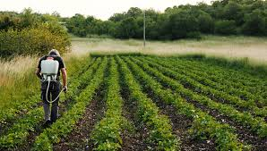

**REFERENCES**

1. <https://ieeexplore.ieee.org/document/9823767/> An automated prediction of crop and fertilizer

diseas using conventional neural network.

1. <https://ieeexplore.ieee.org/document/9825446/> Healthy harvest:Crop prediction and diseas detection system.
2. <https://ieeexplore.ieee.org/document/9714817/> IoT driven artificial intelligence technique for fertilizer recommendation model.

**CONCLUSION**

This paper aims to enhance detection method to detect fertilizer recommendation model for diseases prediction using deep learning techniques . Also result shows that classifiers give better performance when we used more data as training data in future hybrid technology will be implemented to detect fertilizer more acurately .